**Aim**: Create a Trend model using data, Analyse-it and use it for forecasting.

**Theory:**

**Trend line**

Trend lines are used to predict the continuation of a certain trend of a variable. It also helps to identify the correlation between two variables by observing the trend in both of them simultaneously. There are many mathematical models for establishing trend lines. Tableau provides four options. They are Linear, Logarithmic, Exponential, and Polynomial. In this chapter, only the linear model is discussed.

**Forecast**

Forecasting is about predicting the future value of a measure. There are many mathematical models for forecasting. Tableau uses the model known as exponential smoothing. In exponential smoothing, recent observations are given relatively more weight than older observations. These models capture the evolving trend or seasonality of the data and extrapolate them into the future. The result of a forecast can also become a field in the visualisation created.

Dataset use here is the Estimate Dataset.

**Steps:**

Step 1 − Create a line chart with Order Date (Year) in the columns shelf and Sales in the Rows shelf. Go to the Analysis tab as shown in the following screenshot and click Forecast under Model category.

Step 2 − on completing the above step, you will find the option to set various options for forecast. Choose the Forecast Length as 2 years and leave the Forecast Model to Automatic. Click Ok.

You can also get minute details of the forecast model by choosing the option Describe Forecast.

**Output:**

**Trend Line**

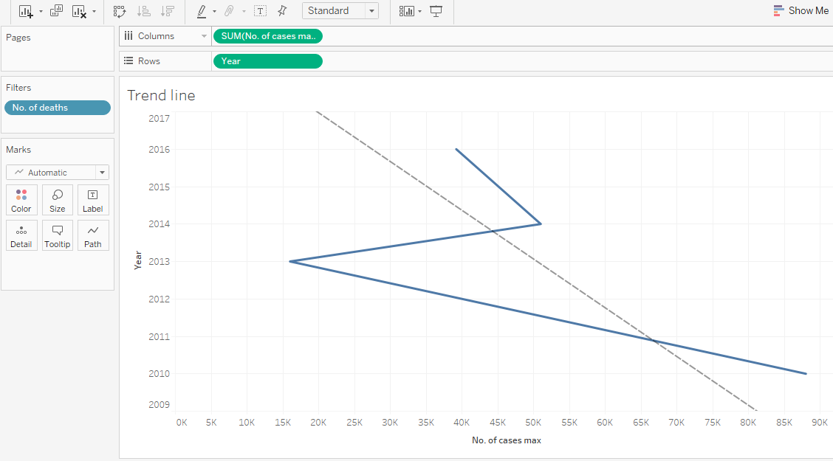

**Forecast**

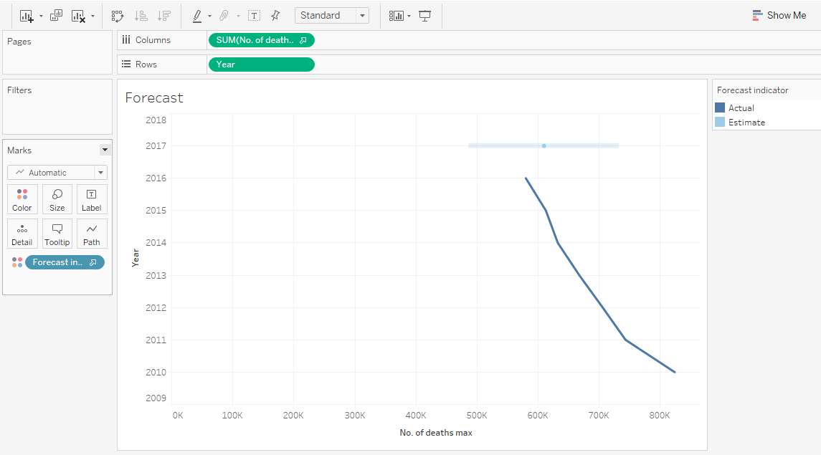

**Forecast Options**

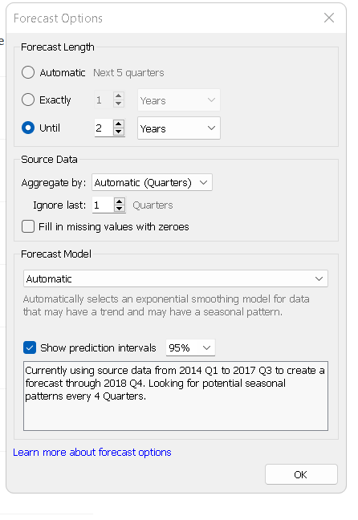

**Describe Forecast**

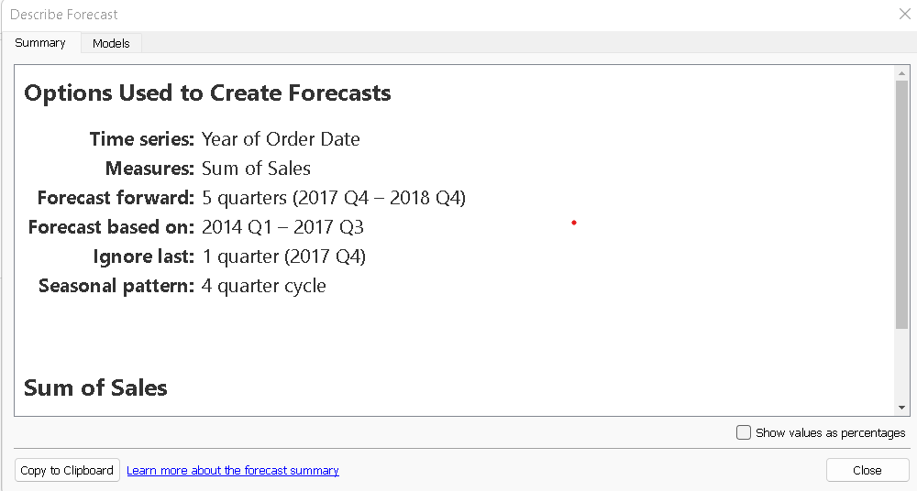

**Result:**

Saw how predict the continuation of a certain trend of a variable and also the predicting the future value of a measure